Movie Landing Page Website Design

Name : Chinnapureddy Anji Reddy

MailId:chinnapureddyanjireddy2@gmail.com

Phn No : 9505855422

Roll N0 : 20HU1A0418

College Name : Chebrolu engineering college

**Source Code:**

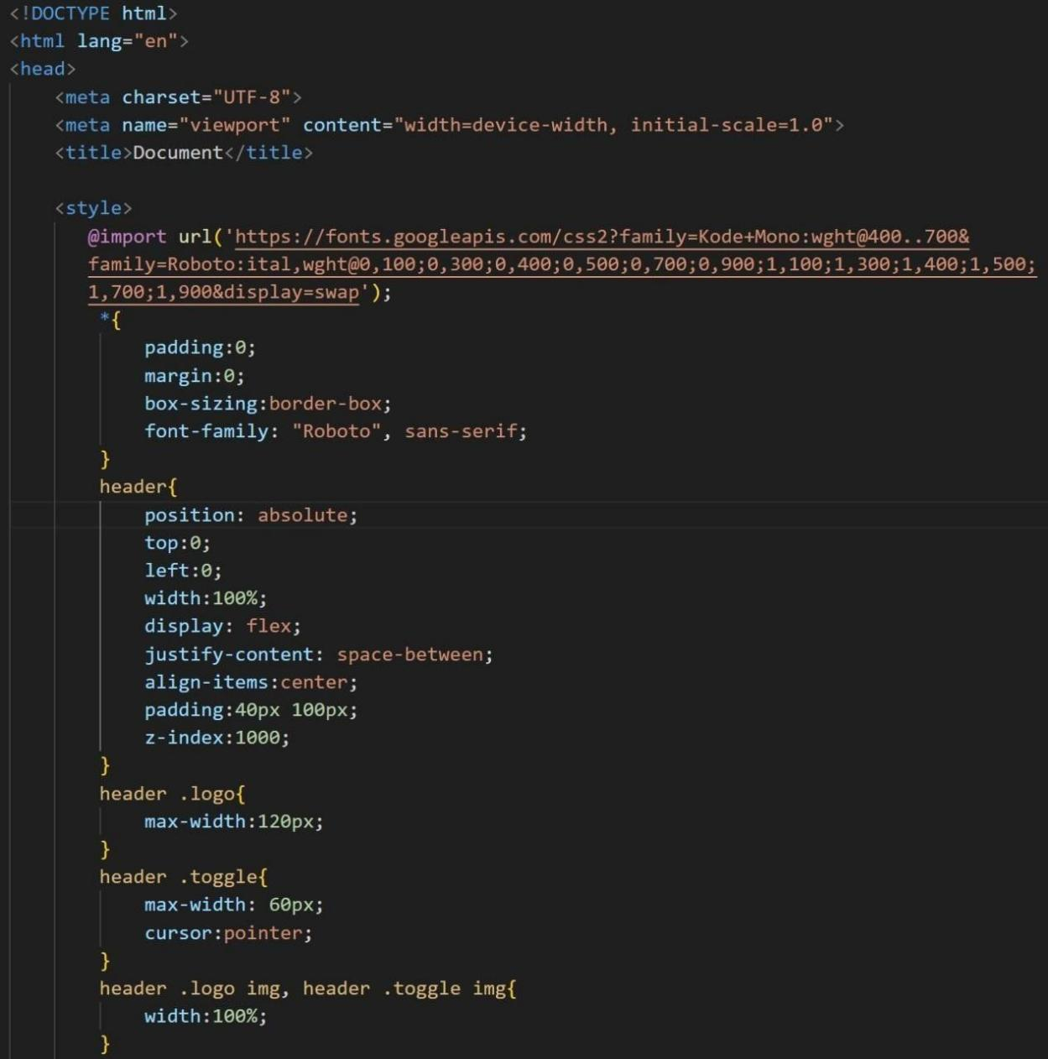

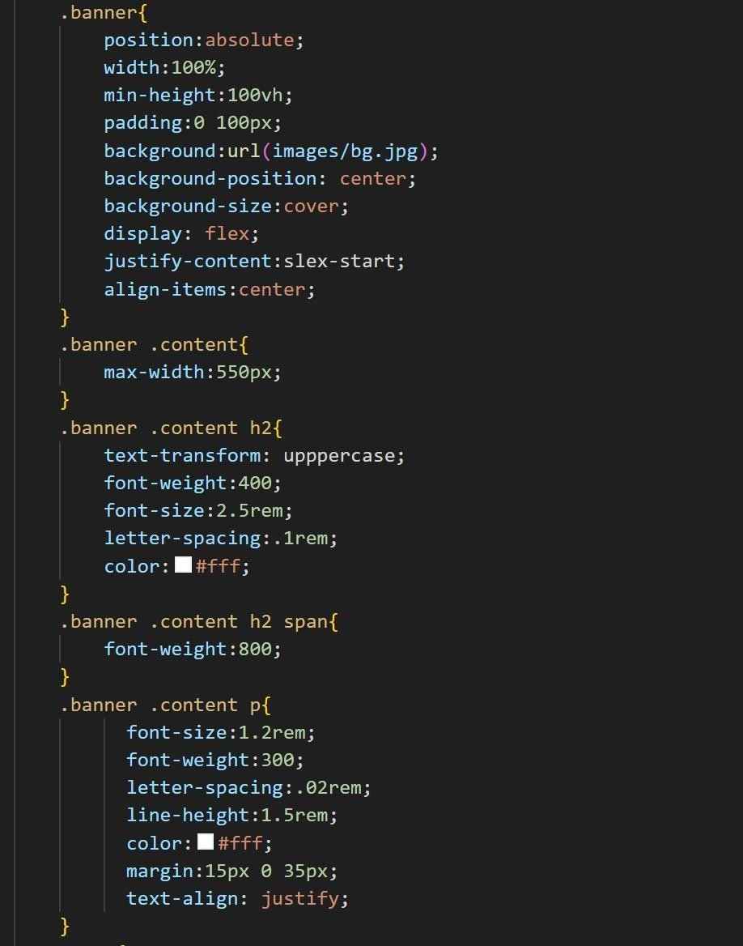

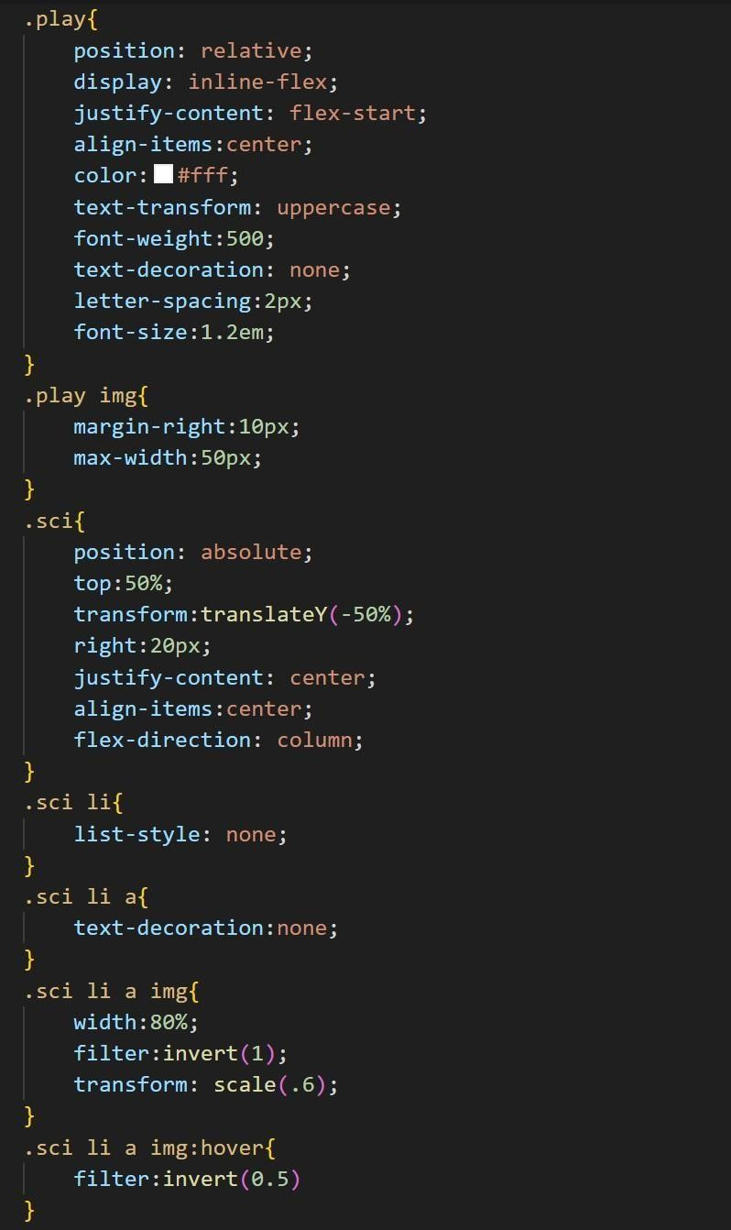

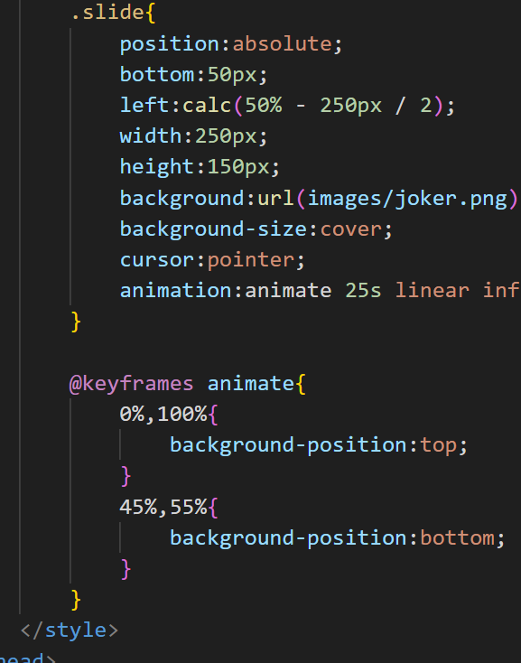

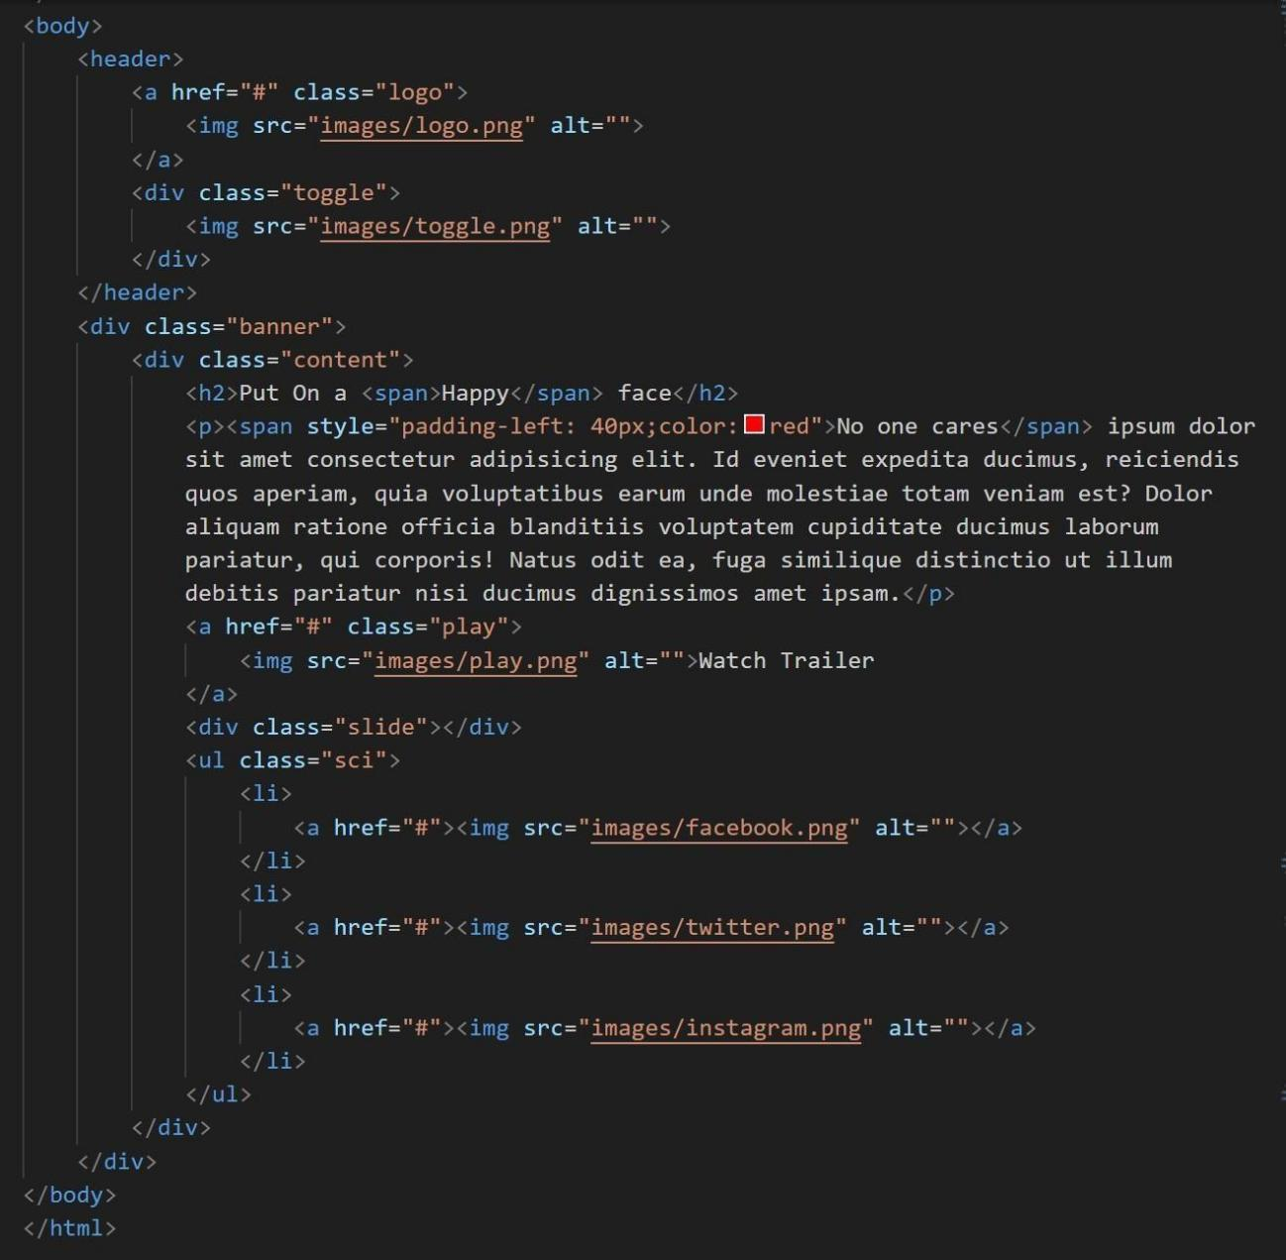



**Output :**